RESUME
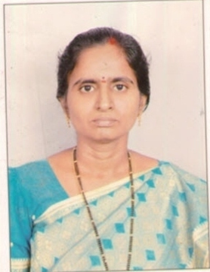
B.Renuka Devi, M.Sc., M.Phil., APSET
Email-Id: renukareddy.msc@gmail.com
Contact no: 8121121962

Career Objective
To work for a professional organization where I can contribute my skills and assume responsibilities and strive for collective growth and development always keeping organization goal as priority.
Educational details
- APSET Qualified in 2017

- M.Phil. Computer Science in 2007 from Alagappa University, Karaikudi, Tamilnadu.

- Post Graduate (M.Sc 1998)
Master of Science in Computer Science from S.K.U., Anantapur.
- Graduate (B.Sc 1993-1996)
Bachelor of Science from S.V.U, Tirupati.
- Intermediate (M.P.C: 1991-1993)
Intermediate (M.P.C) from Board of Intermediate Education, A.P.
- SSC (1991)
Secondary School Certificate (SSC) from Board of Secondary Education, A.P.

Technical Skills

Programming Languages | C, C++,JAVA, Python
Database | SQL, PLSQL, MySQL
Operating System | Windows XP/NT, Windows server 2003
Web Technologies | HTML, Php
Office Tools | MS – Office

Key Strengths
- Good Organizational & Co-ordination Skills.
- Having positive attitude and Quick adaptability to new technologies.
- Good creativity and determination & dedication towards the assigned works.

Work Experience
Worked as a Lecturer in Computer Science from 1999-2005 for a period of 6 years.
Worked as a Lecturer in Computer Science, SKR & SKR Govt. College for Women(A), Kadapa from 2005-2006 to 2021-2022 for a period of 17 years.
Currently working as, a Lecturer in Computer Science, Govt. College for Men(A), Kadapa from 2022-2023.

Papers Published in Journals
1. “PLANNING ERROR REPORTS ON RELATED FILES USING FEATURE EVALUATION SCHEME”, published in International Journal for Innovative Engineering and Management Research, Volume 08, Issue 03, Pages: 167–171, March 2019.
2. “My Privacy My Decision: management of image sharing on on-line Social Networks”, published in Pramana Research Journal, Volume 9, Issue 5, 2019.
3. “THE ROLE OF ARTIFICIAL INTELLIGENCE AND ROBOTICS” published in RED UNICORN PUBLISHING PVT. LTD. Page:126-130.

Personal Profile

- Name : B.Renuka Devi
- Date of Birth : 01-05-1975
- Hobbies : Browsing Internet, Knowing new things.
- Languages Known : English, Telugu, Hindi
- Present Address : 7/306-10,
Bhagya Nagar Colony,
Kadapa-516002.

